Keanu Foltz

Mod 5.2

11/17/24

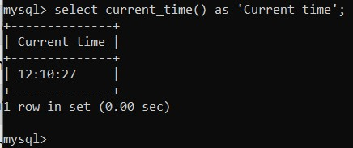

1. The “current time()” function will display the current time, this might be useful for databases that need to compare the amount of time passed from a past time to the current time.   
     
     
   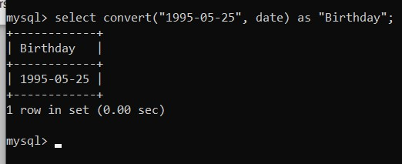
2. The “convert()” function converts data into specific data types. In this case, we have converted the string into a date data type. This can be used when input is stored as a string but needs to be accessed as a date.   
     
   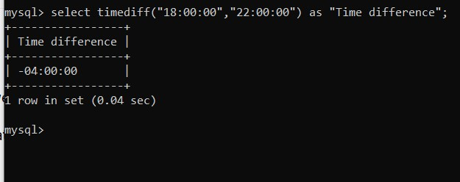
3. The “timediff()” function can be used to calculate the time difference between two different times. This might be useful in a database that stores different timezone data.